

COMPUTATIONAL INTELLIGENCE | MRCET
(CSE – ARTIFICIAL INTELLIGENCE AND MACHINE LEARNING)
Email: mrcetsocse4@mrcet.ac.in
IV Year B. Tech-I Semester Project Phase-1 Summary Sheet

Project Title: | Chatnslate: The Language-Free Chat Experience
Project Code: | R22A6694 |  |  |  | Batch Size: |  | 03 | Batch: |  | 2022-26
Domain/Area: | Web Development / NLP / Real-Time Communication |  |  |  | SDG Mapping: |  | Industry, Innovation and Infrastructure
Abstract: | The Live Language Translator webapp is a smart and easy-to-use tool that helps people from different parts of the world chat with each other, even if they don’t speak the same language. When someone sends a message in their own language, the webapp instantly translates it into the other person’s language, so both can understand each other clearly. It feels just like a normal chat — smooth and instant. This makes it super handy for making new friends across the globe, traveling, learning new languages, or working with international teams. You don’t have to switch apps or copy-paste into a translator — everything happens right there in one place. The webapp is built using Python and uses smart NLP (Natural Language Processing) technology that helps computers understand and translate human language. It also supports real-time messaging, so your chats are instant, just like on WhatsApp or Messenger. Overall, the webapp makes it easy to connect with people from anywhere, break down language barriers, and enjoy smooth, meaningful conversations in any language.
Technical (S/w & H/w) Specifications |  |  |  | Module(s) Specifications
 |  |  |  | Module 1: User Authentication & Login  Module 2: Real-Time Messaging Interface  Module 3: Language Detection & Translation API Integration  Module 4: Multilingual Chat Engine  Module 5: Socket or Realtime Communication Handler  Module 6: UI/UX Design and Localization Features
  Software Specifications | Hardware Specifications
  - Frontend: HTML, CSS, JS  - Python 3.12  - API: Google Translate API  - Messaging Layer: Socket.IO, Firebase Realtime | - Processor: intel i5 or above  - Memory: 4GB or above  - Hard Disk: 128GB  - Internet Connectivity
Architecture Diagram |  |  |  | Methodology
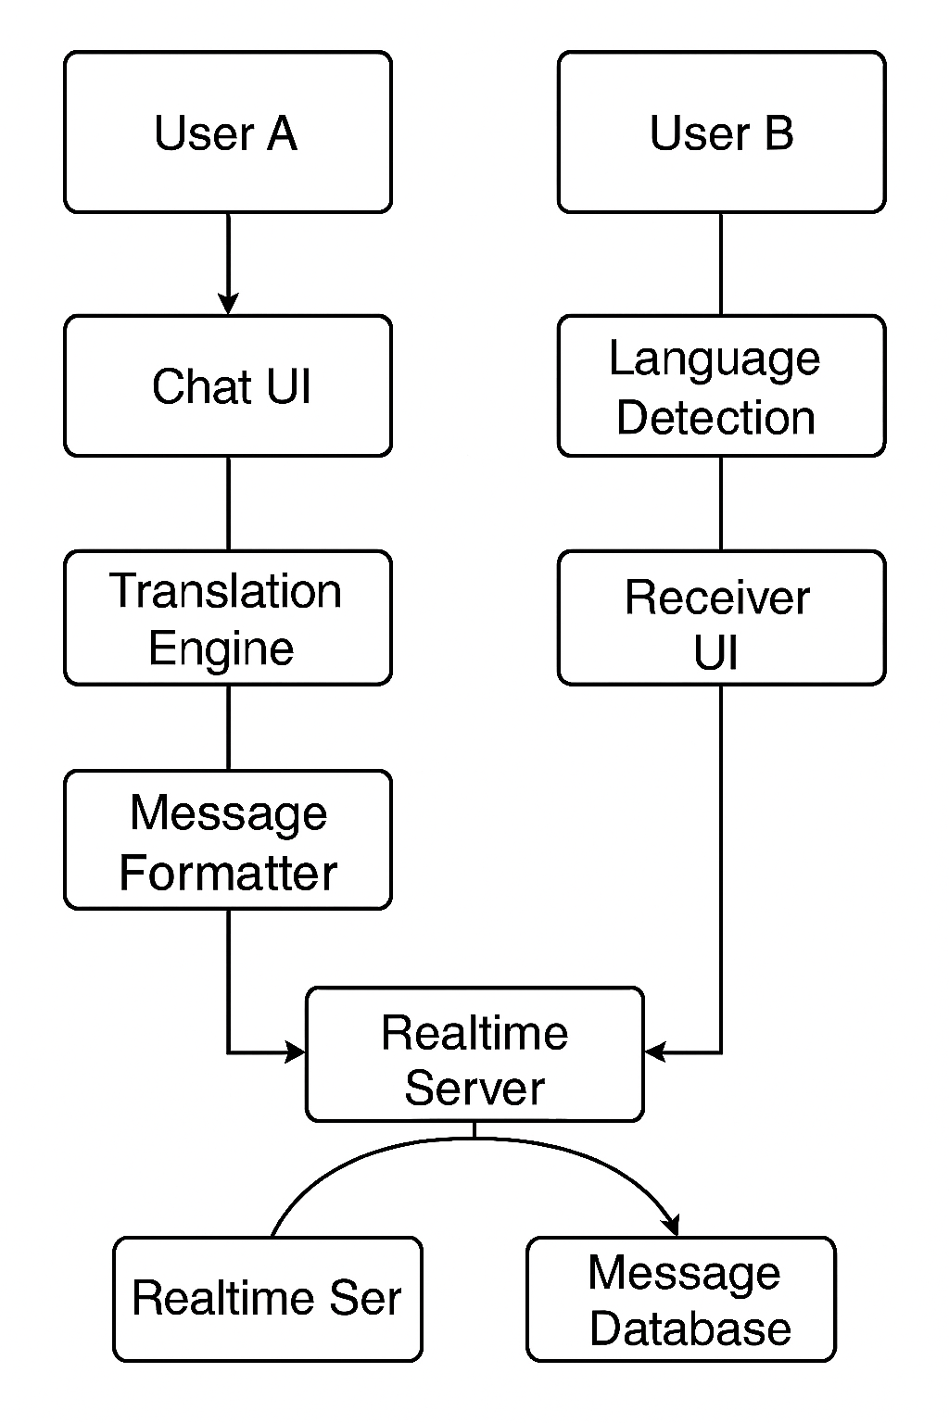 |  |  |  | - Analysis: Identified communication gap due to language diversity in global digital conversations.  - Design: Planned a chat-first interface integrated with multilingual translation using NLP APIs.  - Development: Built frontend, backend, real-time communication, and integrated translation services.  - Testing: Verified message delivery, translation accuracy, and UI responsiveness across browsers.  - Deployment: Hosted locally or via cloud; tested with multiple languages.  - Maintenance: Iteratively improved model integration and added language support.
Existing System |  |  |  | Proposed System
- Manual translation through separate apps (e.g., Google Translate).  - No real-time multilingual chat solutions.  - Communication barriers in international teams or social contexts. |  |  |  | - One unified platform for chatting and translation.  - NLP-powered real-time translation.  - Eliminates need to switch platforms or translate manually.  - Promotes inclusive, cross-border communication.
Guide Details |  |  | Batch Members Details
 |  | Mr. S. Venkateshwara Raju  Associate  Professor in Department of CI  MRCET Campus  UGC Autonomous Institution  -Govt. of India Hyderabad |  |  |  |  |  |  | 
 |  |  | Bheemanapally Abhaya Sri |  |  | Bochkar Nikhith |  |  | Jakkireddy Sri Charan Reddy
 |  |  | 22N31A6627 |  |  | 22N31A6629 |  |  | 22N31A6666

